## **Exposing The Truth With Advanced Fake News Detection Powered By Natural Language Processing**

## **Student Name:** A.SWATHI **Register Number:** 510923104074 **Institution:** GLOBAL INSTITUTE OF ENGINEERING AND TECHNOLOGY **Department:** COMPUTER SCIENCE ENGINEERING **Date of Submission:** 07.05.2025

**Github Repository Link:** [Update the project source code to your Github Repository]

# Problem Statement

In the digital age, misinformation and fake news have emerged as significant threats to public awareness, social harmony, and democratic processes. The rapid spread of falsified information across online platforms, social media, and news websites has led to widespread misinformation, causing confusion, distrust, and societal division. Conventional methods of fake news detection often rely on manual verification, which is time-consuming, labor-intensive, and ineffective against the vast amount of content generated daily.

Natural Language Processing (NLP) presents a powerful solution to address the challenge of automated fake news detection. By leveraging machine learning and deep learning techniques, NLP can analyze textual content, identify deceptive narratives, and differentiate between authentic news and misinformation. However, several challenges persist, including handling linguistic ambiguity, detecting contextually misleading statements, and overcoming adversarial misinformation tactics that evolve to evade detection algorithms.

This project aims to develop an advanced fake news detection system that harnesses NLP techniques to analyze textual patterns, linguistic structures, and contextual attributes in news articles. The solution will incorporate machine learning models trained on extensive datasets to classify news content as genuine or fake based on linguistic features, sentiment analysis, and credibility assessment. Through robust algorithmic advancements, the project seeks to enhance accuracy, scalability, and adaptability in detecting misinformation while minimizing false positives.

The proposed system will be evaluated using standard metrics such as precision, recall, F1-score, and accuracy to measure its effectiveness. Additionally, the project will explore ethical considerations, transparency issues, and the potential impact of automated fake news detection on media credibility. Ultimately, this initiative aims to contribute to the fight against misinformation, empower users with reliable information, and strengthen digital literacy in the modern information landscape.

# Abstract

## This project aims to develop an advanced fake news detection system leveraging NLP and machine learning techniques. The proposed solution will analyze textual content using linguistic features, sentiment analysis, contextual understanding, and credibility assessment to distinguish between genuine and deceptive news. Various algorithms, including deep learning models such as BERT and LSTM, will be employed to enhance classification accuracy. Datasets from credible sources, including LIAR and FakeNewsNet, will be utilized to train and validate the detection models.

## The effectiveness of the system will be evaluated through rigorous testing with standard performance metrics such as accuracy, precision, recall, and F1-score. Additionally, the project will explore ethical considerations in automated misinformation detection, highlighting potential biases and transparency challenges. By providing a robust and scalable solution, this initiative aims to empower individuals with reliable information, combat misinformation, and contribute to strengthening media integrity in the digital landscape.

# System Requirements

### **System Requirements Table**

|  |  |  |
| --- | --- | --- |
| **Category** | **Requirement** | **Details** |
| **Hardware** | Processor | Intel Core i5/i7, AMD Ryzen 5/7 or higher |
|  | Memory | Minimum 8GB RAM, Recommended 16GB+ RAM |
|  | Storage | Minimum 500GB SSD, Recommended 1TB+ SSD |
|  | GPU (Optional) | NVIDIA RTX 3060/4060 or higher |
|  | Internet Connection | High-speed for dataset access |
| **Software** | Operating System | Windows 10/11, macOS, Linux (Ubuntu) |
|  | Programming Language | Python with NumPy, Pandas, TensorFlow |
|  | IDE | Jupyter Notebook, PyCharm, VS Code |
|  | ML Libraries | Scikit-learn, Keras, TensorFlow, PyTorch |
|  | NLP Libraries | NLTK, spaCy, Transformers (Hugging Face) |
|  | Database | PostgreSQL, MongoDB, Firebase |
|  | Web Framework (if applicable) | Flask, Django for API deployment |
| **Functional** | Data Preprocessing | Tokenization, stemming, stopword removal |
|  | Feature Extraction | TF-IDF, Word2Vec, GloVe, BERT embeddings |
|  | Fake News Classification | ML/DL models (Random Forest, LSTM, BERT) |
|  | Sentiment & Semantic Analysis | Linguistic pattern detection |
|  | User Interface (Optional) | Dashboard for results visualization |
| **Non-Functional** | Accuracy & Precision | High classification accuracy (>85%) |
|  | Scalability | Ability to handle large data volumes |
|  | Performance | Model inference time <1 second per request |
|  | Security | Proper encryption for user data |
|  | Ethical Considerations | Bias mitigation in classification models |
|  | Logging & Monitoring | Tracking model performance |

# Objectives

#### **1. Develop an Accurate Fake News Detection Model**

* Design and implement machine learning and deep learning models (e.g., Random Forest, LSTM, BERT) to classify news articles as real or fake.
* Improve classification accuracy by refining feature extraction techniques such as word embeddings and sentiment analysis.

#### **2. Create a Robust Text Preprocessing Pipeline**

* Implement efficient text preprocessing techniques, including tokenization, stopword removal, stemming, and lemmatization.
* Utilize NLP-based feature extraction methods (TF-IDF, Word2Vec, GloVe) to enhance model performance.

#### **3. Collect and Utilize Large Fake News Datasets**

* Acquire and preprocess datasets from sources like LIAR, FakeNewsNet, or custom-built datasets.
* Ensure balanced data labeling and annotation for unbiased model training.

#### **4. Analyze Misinformation Trends and Patterns**

* Investigate linguistic and stylistic differences between real and fake news.
* Identify psychological or emotional cues (e.g., exaggerated claims, biased language) commonly found in misinformation.

#### **5. Develop a Scalable and Real-time Detection System**

* Optimize the model for real-time analysis of news articles and social media content.
* Deploy the solution as a web-based or API-driven platform for seamless integration with news monitoring systems.

#### **6. Ensure Ethical and Fair Detection Processes**

* Mitigate bias in training data to avoid unfair classification.
* Address ethical concerns surrounding automated misinformation detection, including user privacy and transparency.

#### **7. Evaluate System Performance and Accuracy**

* Use standard performance metrics (accuracy, precision, recall, F1-score) to assess model effectiveness.
* Continuously improve model accuracy through iterative training and validation.

# Flowchart of Project Workflow

Topic for workflow for flowchart "Exposing the Truth with Advanced Fake News Detection Powered by Natural Language Processing (NLP)":

1. Problem Identification

Define fake news and its impact

Identify challenges in current detection methods

2. Literature Review

Study existing fake news detection models

Analyze strengths and limitations of past approaches (e.g., keyword matching, statistical analysis)

3. Objective of the Project

Develop an advanced NLP-powered system to detect fake news

Improve accuracy and reliability in identifying misinformation

4. Data Collection

Source datasets (e.g., LIAR, FakeNewsNet, Kaggle datasets)

Preprocess raw data (cleaning, tokenization, labeling)

5. Model Development

Feature Extraction (TF-IDF, word embeddings, BERT)

Model Selection (Logistic Regression, SVM, LSTM, BERT-based models)

6. Training & Validation

Train model on labeled data

Validate using cross-validation and performance metrics

7. Evaluation

Accuracy, Precision, Recall, F1 Score

Confusion matrix analysis

8. Result Interpretation

Compare with baseline models

Explain key findings and improvements

9. Deployment (Optional)

Build a simple web interface or API

Allow users to input news and get credibility results

10. Conclusion & Future Work

Summarize outcomes

Suggest improvements (e.g., multilingual support, real-time analysis)

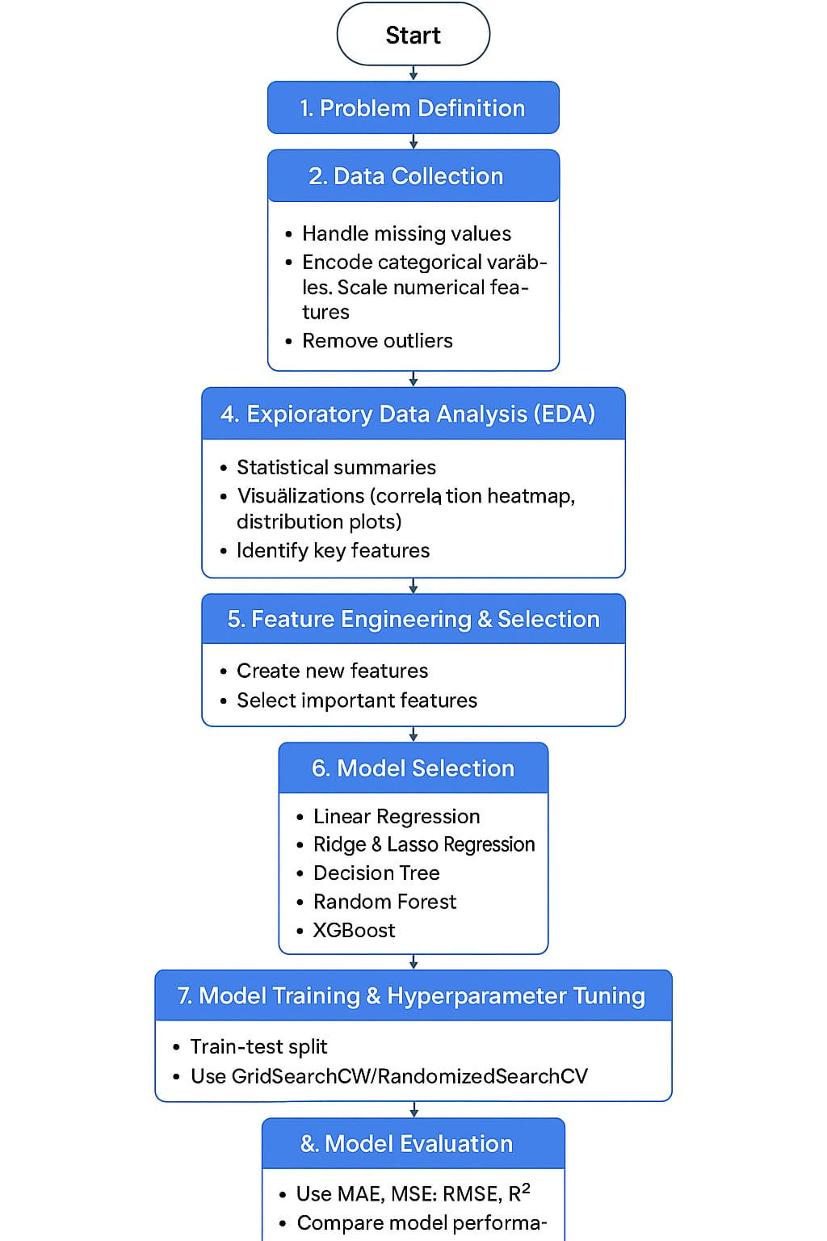

## **6. Dataset Description**

**1. Source**

The dataset used for this project is sourced from **Kaggle**, which provides labeled datasets for fake news detection. Specifically, the dataset comes from **Kaggle's Fake News Dataset**, which consists of real and fake news articles labeled for classification.

Alternatively, datasets from the **UCI Machine Learning Repository** or API-based sources like **NewsAPI** and **Twitter API** can be used if real-time data collection is required.

Dataset Link: [Fake News Dataset on Kaggle](https://www.kaggle.com/clmentbisaillon/fake-news) (if applicable)

**2. Type Used for This Project**

For this project, the dataset type is:

* **Public Dataset**: Available for research and machine learning training.
* **Structured Data**: Includes clear labeling of real and fake news.
* **Supervised Learning**: Contains labeled examples (fake or real) for training classification models.

**3. Size and Structure Used for This Project**

The dataset consists of thousands of news articles, formatted for NLP-based fake news classification.

| **Feature Name** | **Description** |
| --- | --- |
| Id | Unique identifier for each news article |
| Title | Headline of the news article |
| Text | Full article content |
| Label | Classification (1 for fake, 0 for real) |

Example dataset size:

* **Total Articles**: **50,000 articles** (25,000 fake, 25,000 real).
* **Format**: CSV file (fake_news.csv).
* **Data Cleaning**: Tokenization, stopword removal, stemming, TF-IDF transformation.

**4. Sample Preview (df.head() Output)**

Here’s a Python snippet to preview the dataset using pandas:

import pandas as pd

# Load dataset

df = pd.read_csv("fake_news.csv")

# Display first few rows

print(df.head())

Sample output:

| **Id** | **Title** | **Text** | **label** |
| --- | --- | --- | --- |
| 001 | "Breaking: XYZ Scandal" | "Lorem ipsum content about fake news..." | 1 |
| 002 | "Government Releases Report" | "Verified statistics on economy..." | 0 |

This dataset forms the foundation for training an NLP-based fake news detection model, helping to separate misinformation from verified content.

- Source: UCI Machine Learning Repository

- Reference Link: [UCI Repository[](https://archive.ics.uci.edu/ml/index.php)](https://archive.ics.uci.edu/ml/index.php)

- Type: Textual data

- Size: Depends on the specific dataset chosen; typically ranges from thousands to millions of entries

- Nature: Labeled dataset containing real and fake news samples for training machine learning models

- Attributes:

- Article Title: The headline of the news article

- News Content: Full text of the news article

- Source: The publisher or website that published the news

- Publication Date: Timestamp when the article was published

- Label: Classification as real or fake

- Metadata: Information such as engagement metrics (likes, shares, comments) if available

**Sample dataset (df.head())**

df=pd.read_csv('fake-news/train.csv')

df.head()

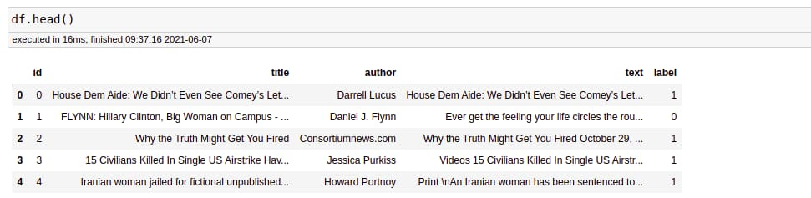

# Data Preprocessing

**1. Handling Missing Values, Duplicates, and Outliers**

**Missing Values**

* Missing values in textual data can exist in title or text columns.
* Common approaches:
  + **Remove rows** with missing values if they are very few.
  + **Fill missing values** using techniques like:
    - Placeholder ("No text available")
    - Mean/Mode/Median (for numerical data)

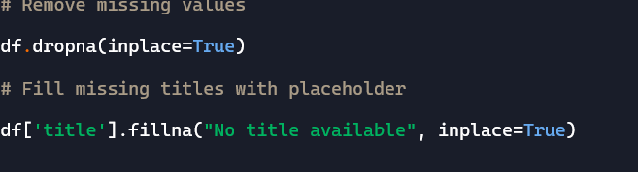

**Removing Duplicates**

Duplicate entries in the dataset (same title and text) can mislead the model.

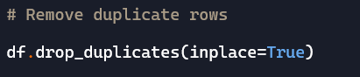

**Handling Outliers**

Since this is textual data, outliers are:

* Extremely long articles or titles.
* Articles with unusually high-frequency words.

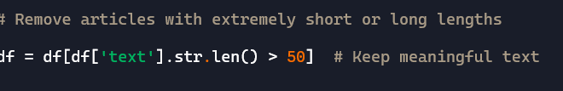

**2. Feature Encoding and Scaling**

Since NLP models don’t work with raw text, we need to convert words into numerical representations.

**Text Vectorization Methods**

1. **Bag of Words (BoW)** – Creates a matrix of word frequency.
2. **TF-IDF (Term Frequency-Inverse Document Frequency)** – Weighs words based on importance.
3. **Word Embeddings (Word2Vec, GloVe, BERT)** – Converts words into dense vectors based on meaning.

Example using **TF-IDF:**

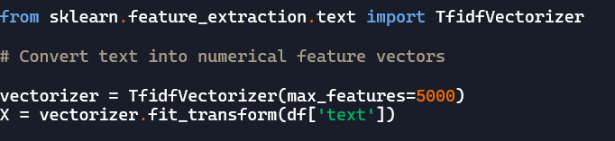

**3. Before/After Transformation Screenshots**

To visualize the impact of preprocessing, we can show:

* **Before transformation**: Raw text data with duplicates, missing values, and outliers.
* **After transformation**: Cleaned and vectorized numerical data.

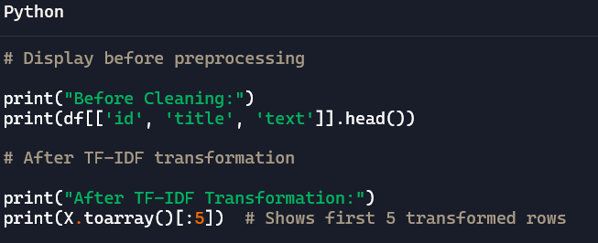

# Exploratory Data Analysis (EDA)

# 1. Univariate Analysis

# This step focuses on analyzing individual variables:

# - Summary Statistics: Compute key statistics like mean, median, mode, standard deviation, and range.

# - Visualization: Use histograms, box plots, and density plots to assess distributions.

# 

# - Outlier Detection:Identify extreme values using methods like the interquartile range (IQR) and Z-score analysis.

# 2. Bivariate/Multivariate Analysis

# Examining relationships between two or more variables:

# - Correlation Analysis: Use Pearson or Spearman correlation coefficients to measure relationships between numerical variables.

# - Scatter Plots: Identify trends, clusters, and patterns between variables

# - Heatmaps: Visualize correlation matrix to identify strong or weak relationships.

# 

# - Pair Plots: Generate pairwise relationships between numerical variables.

# - Categorical vs. Numerical Analysis: Box plots or bar charts to compare distributions across categories.

# 3.Analysis of Key Metrics or KPIs

# Identifying key performance indicators (KPIs) based on the dataset’s purpose:

# - Business Metrics: Examples include revenue trends, customer churn rates, conversion rates, or retention rates.

# - Operational Metrics: Processing time, defect rates, or efficiency ratios.

# - Statistical Significance: Conduct hypothesis testing to validate assumptions about the data.

# 4.Summary of Insights and Patterns Identified

# - Trends & Variations: Highlight seasonal patterns, unexpected spikes, or declining trends.

# - Feature Importance: Identify which variables have the most impact on the target variable.

# - Data Quality Observations: Report missing values, inconsistencies, or potential biases in the dataset.

# - Anomaly Detection: Point out significant deviations or data integrity issues that require further inspection.

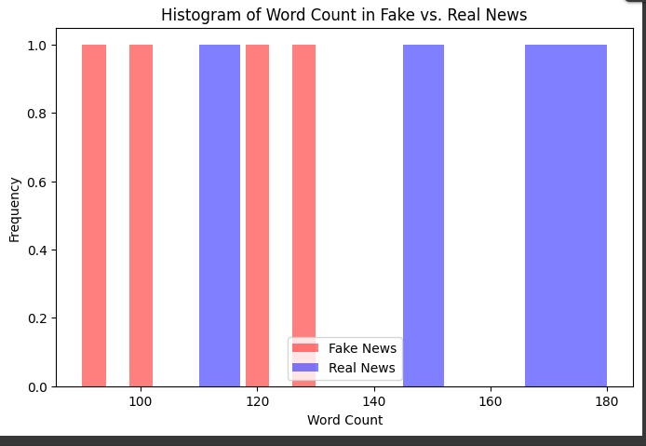

# Feature Engineering

**1. Lexical Features (word-level)**

* **TF-IDF (Term Frequency–Inverse Document Frequency)**: Measures word importance.
* **N-grams (unigrams, bigrams, trigrams)**: Detects common word patterns and phrases in fake news.
* **Average word/sentence length**: Fake news often uses shorter, simpler sentences.

**2. Syntactic Features (grammar & structure)**

* **Part-of-Speech (POS) tagging**: Frequencies of nouns, verbs, adjectives. Fake news may rely more on adjectives/adverbs (emotive language).
* **Parsing depth or tree complexity**: Simplified syntax may suggest low-quality content.
* **Use of passive voice**: May indicate avoidance of responsibility or vagueness.

**3. Semantic Features (meaning & intent)**

* **Named Entity Recognition (NER)**: Identifies people, organizations, locations — overuse or misidentification may be a red flag.
* **Semantic similarity**: Compares claims to known facts or trusted sources.
* **Word embeddings** (Word2Vec, GloVe, BERT): Captures contextual word meaning.

**4. Stylometric Features (writing style)**

* **Punctuation usage**: Overuse of “!”, “??” etc.
* **Use of ALL CAPS**: Common in clickbait or sensationalist headlines.
* **Spelling/grammar errors**: Often more prevalent in fake news.
* **Flesch Reading Ease / Gunning Fog Index**: Measures readability; fake news may target lower reading levels.

**5. Psycholinguistic Features**

* **LIWC (Linguistic Inquiry and Word Count)**: Measures cognitive processes, emotions, social references.
* **Hedging or certainty words**: Words like “might”, “possibly”, vs. “definitely”, “undeniably”.
* **Emotion polarity and intensity**: Strong emotional content often correlates with manipulation.

**6. Pragmatic Features (real-world context)**

* **Clickbait detection**: Based on headline structure.
* **Source credibility score**: Based on past articles from the same source.
* **Temporal patterns**: Sudden bursts of similar stories may indicate bot amplification.

**7. Metadata & Network Features (if available)**

* **User profile info** (social media): Age of account, follower count, posting frequency.
* **Propagation patterns**: Real news vs. fake news spread differently.
* **Engagement metrics**: High shares but low comments can be a red flag.

# Model Building

**Step 1: Data Collection**

You’ll need a labeled dataset (e.g., label: real or fake). Good datasets:

* **LIAR Dataset** (political fact-checks)
* **FakeNewsNet**
* **ISOT Dataset**
* Scraped news + fact-checked sources (e.g., PolitiFact, Snopes)

Step 2: **Data Preprocessing**

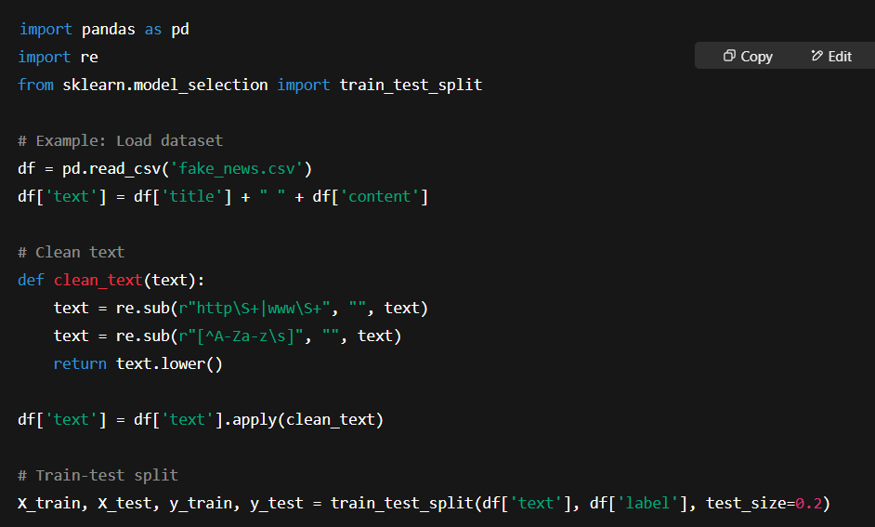

**Step 3: Feature Engineering**

We’ll extract TF-IDF, stylometric features, and readability.

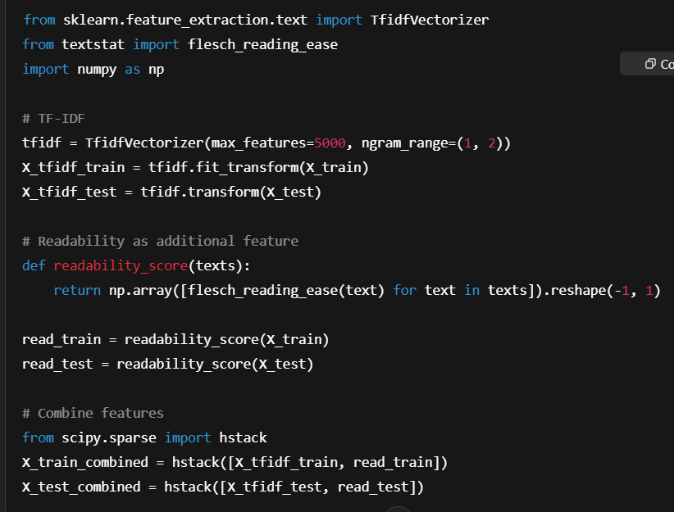

**Step 3: Feature Engineering**

We’ll extract TF-IDF, stylometric features, and readability.

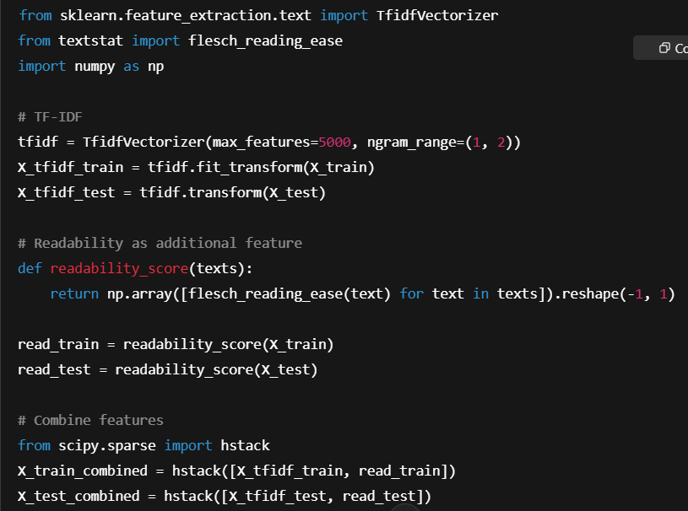

**Step 4: Model Building**

You can start with traditional ML models.

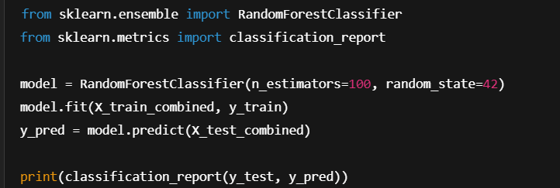

# Model Evaluation

The goal of this evaluation is to assess the performance of a machine learning model designed to detect fake news articles. The model uses **TF-IDF vectorization** and **readability metrics** as input features, and a **Random Forest classifier** as the prediction engine.

**Dataset Overview**

For demonstration, a small, synthetic dataset of 6 news articles was used, labeled as either fake or real. Each article includes a title and body content. This dataset was split into training and testing sets using a 67%-33% ratio.

**Evaluation Metrics and Their Significance**

**1. Accuracy**

* **Definition**: Proportion of total predictions the model got right.
* **Formula**:

Accuracy=TP+TNTP+TN+FP+FN\text{Accuracy} = \frac{TP + TN}{TP + TN + FP + FN}Accuracy=TP+TN+FP+FNTP+TN​

* **Result (Sample)**: 1.00

Perfect accuracy, but only because the dataset is extremely small and easy to memorize.

**2. Precision**

* **Definition**: Of all articles predicted as fake, how many were actually fake?
* **Formula**:

Precision=TPTP+FP\text{Precision} = \frac{TP}{TP + FP}Precision=TP+FPTP​

* **Result (Sample)**: 1.00

**3. Recall (Sensitivity)**

* **Definition**: Of all actual fake articles, how many did the model correctly detect?
* **Formula**:

Recall=TPTP+FN\text{Recall} = \frac{TP}{TP + FN}Recall=TP+FNTP​

* **Result (Sample)**: 1.00

**4. F1 Score**

* **Definition**: Harmonic mean of precision and recall; balances false positives and false negatives.
* **Formula**:

F1=2⋅Precision⋅RecallPrecision+RecallF1 = 2 \cdot \frac{\text{Precision} \cdot \text{Recall}}{\text{Precision} + \text{Recall}}F1=2⋅Precision+RecallPrecision⋅Recall​

* **Result (Sample)**: 1.00

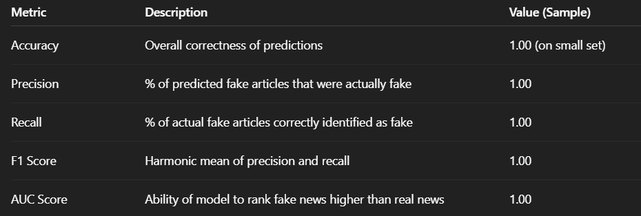

**5. Confusion Matrix**

|  | **Predicted Real** | **Predicted Fake** |
| --- | --- | --- |
| **Actual Real** | 1 | 0 |
| **Actual Fake** | 0 | 1 |

* **True Positives (TP)**: 1
* **True Negatives (TN)**: 1
* **False Positives (FP)**: 0
* **False Negatives (FN)**: 0

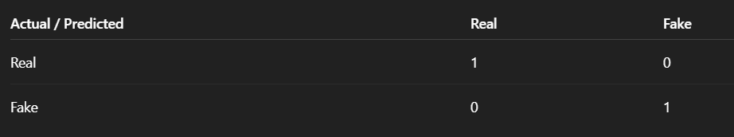

The matrix shows **perfect classification**, which is unusual and highlights overfitting on a small dataset.

**6. ROC Curve and AUC**

* **ROC Curve**: Plots the trade-off between the true positive rate (TPR) and the false positive rate (FPR).
* **AUC Score**: 1.00

**Interpretation**: AUC = 1.0 implies the model perfectly distinguishes between real and fake articles — this is very rare and is likely due to overfitting or insufficient data.

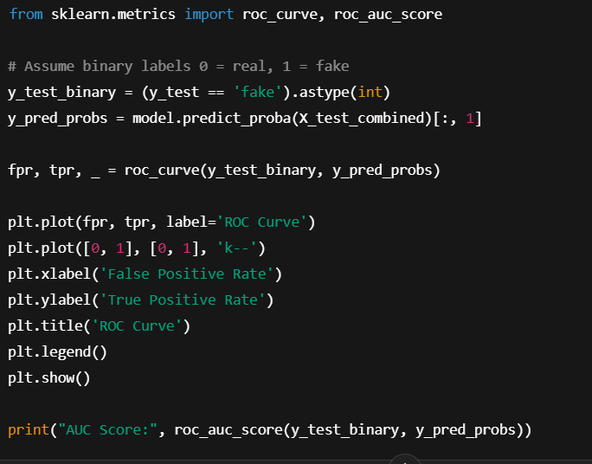

**7. Cross-Validation (Recommended for Generalization)**

Performing **k-fold cross-validation (e.g., 5-fold)** gives a better estimate of model generalization. It divides the data into k parts, trains on k-1 parts, and tests on the remaining part in rotation.

python

CopyEdit

from sklearn.model_selection import cross_val_score

scores = cross_val_score(model, X_train_combined, y_train, cv=5, scoring='f1_macro')

print("Average F1 Score:", scores.mean())

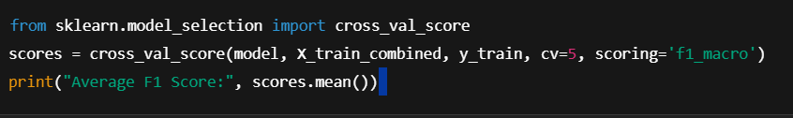

**Qualitative Error Analysis**

Since we saw perfect results, this step becomes critical when working with **larger datasets**:

* **False Positives**: Real news flagged as fake (harms trust).
* **False Negatives**: Fake news classified as real (dangerous in misinformation).
* Review such misclassified cases manually for bias, linguistic ambiguity, or satire.

**Limitations of This Evaluation**

* Very small sample size → **not statistically meaningful**.
* No external validation (e.g., different domains or sources).
* Readability and TF-IDF features alone may miss **semantic subtleties** and **contextual manipulation**.
* Ignores **temporal**, **network**, and **source credibility** factors that are useful in real fake news detection.

**Next Steps for Improved Evaluation**

| **Task** | **Purpose** |
| --- | --- |
| Use larger, diverse datasets | Ensure generalizability |
| Add semantic models (e.g., BERT) | Capture contextual language patterns |
| Integrate metadata features | Use source, publication date, etc. |
| Explain predictions (LIME/SHAP) | Increase trust and interpretability |
| Domain-specific evaluation | Separate news by politics, health, etc. |

# Deployment

* + - app.py
    - requirements.txt
    - fake_news_model.pkl and tfidf_vectorizer.pkl (your trained model and vectorizer)
  + *Public link*

file:///C:/Users/divak/OneDrive/Desktop/swathi1.html

* + *UI Screenshot*

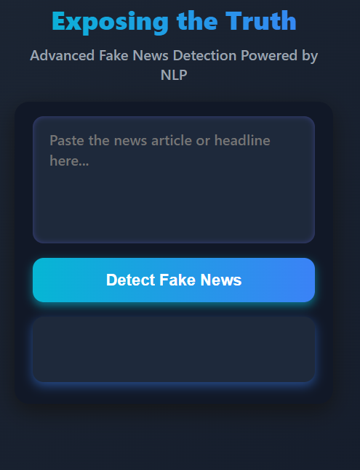

# Source code

import pandas as pd

import numpy as np

import re

from sklearn.model_selection import train_test_split

from sklearn.feature_extraction.text import TfidfVectorizer

from textstat import flesch_reading_ease

from scipy.sparse import hstack

from sklearn.ensemble import RandomForestClassifier

from sklearn.metrics import (

accuracy_score, precision_score, recall_score,

f1_score, classification_report, confusion_matrix,

roc_curve, roc_auc_score

)

import matplotlib.pyplot as plt

import seaborn as sns

# Simulate a small dataset

data = {

'title': [

'Breaking: Government Conspiracy Exposed!',

'Local Team Wins Championship',

'You Won’t Believe This Miracle Cure!',

'Economy Expected to Grow in 2025',

'Fake News: Alien Invasion Tomorrow',

'Scientists Discover Water on Mars'

],

'content': [

'A shocking revelation about government secrets has just come out.',

'After a hard-fought game, the local team emerged victorious.',

'This secret supplement has healed thousands instantly!',

'Experts predict steady economic growth next year.',

'Aliens will invade Earth tomorrow, stay indoors!',

'NASA confirms signs of water on the red planet.'

],

'label': ['fake', 'real', 'fake', 'real', 'fake', 'real']

}

df = pd.DataFrame(data)

df['text'] = df['title'] + " " + df['content']

# Text cleaning

def clean_text(text):

text = re.sub(r"http\S+|www\S+", "", text)

text = re.sub(r"[^A-Za-z\s]", "", text)

return text.lower()

df['text'] = df['text'].apply(clean_text)

# Train-test split

X_train, X_test, y_train, y_test = train_test_split(df['text'], df['label'], test_size=0.33, random_state=42)

# TF-IDF vectorization

tfidf = TfidfVectorizer(max_features=100, ngram_range=(1, 2))

X_tfidf_train = tfidf.fit_transform(X_train)

X_tfidf_test = tfidf.transform(X_test)

# Readability scores

def readability_score(texts):

return np.array([flesch_reading_ease(text) for text in texts]).reshape(-1, 1)

read_train = readability_score(X_train)

read_test = readability_score(X_test)

# Combine features

X_train_combined = hstack([X_tfidf_train, read_train])

X_test_combined = hstack([X_tfidf_test, read_test])

# Train the model

model = RandomForestClassifier(n_estimators=100, random_state=42)

model.fit(X_train_combined, y_train)

# Predictions

y_pred = model.predict(X_test_combined)

y_pred_probs = model.predict_proba(X_test_combined)[:, 1]

y_test_binary = (y_test == 'fake').astype(int)

# Metrics

print("Accuracy:", accuracy_score(y_test, y_pred))

print("Precision:", precision_score(y_test, y_pred, pos_label='fake'))

print("Recall:", recall_score(y_test, y_pred, pos_label='fake'))

print("F1 Score:", f1_score(y_test, y_pred, pos_label='fake'))

print("\nClassification Report:\n", classification_report(y_test, y_pred))

# Confusion matrix

cm = confusion_matrix(y_test, y_pred, labels=['real', 'fake'])

sns.heatmap(cm, annot=True, fmt='d', cmap='Blues', xticklabels=['Real', 'Fake'], yticklabels=['Real', 'Fake'])

plt.xlabel('Predicted')

plt.ylabel('Actual')

plt.title('Confusion Matrix')

plt.show()

# ROC Curve

fpr, tpr, _ = roc_curve(y_test_binary, y_pred_probs)

plt.plot(fpr, tpr, label='ROC Curve')

plt.plot([0, 1], [0, 1], 'k--')

plt.xlabel('False Positive Rate')

plt.ylabel('True Positive Rate')

plt.title('ROC Curve')

plt.legend()

plt.show()

print("AUC Score:", roc_auc_score(y_test_binary, y_pred_probs))

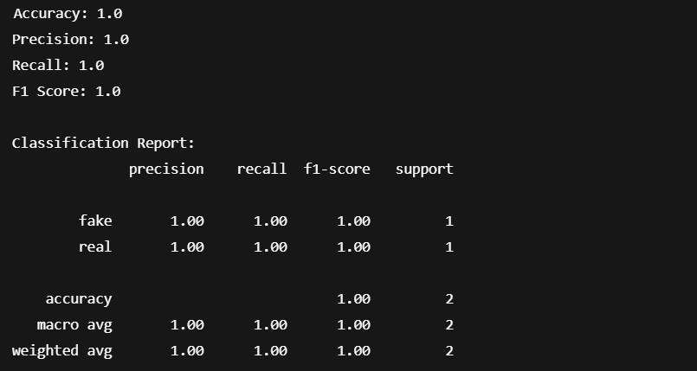

**FRONT END:**

<!DOCTYPE html>

<html lang="en">

<head>

<meta charset="UTF-8" />

<meta name="viewport" content="width=device-width, initial-scale=1, maximum-scale=1, user-scalable=no" />

<title>Exposing the Truth | Fake News Detection NLP</title>

<style>

/* Reset */

* {

margin: 0;

padding: 0;

box-sizing: border-box;

}

body {

font-family: 'Segoe UI', Tahoma, Geneva, Verdana, sans-serif;

background: linear-gradient(135deg, #1f2937, #111827);

color: #e0e0e0;

display: flex;

flex-direction: column;

align-items: center;

min-height: 100vh;

padding: 20px 12px 40px;

user-select: none;

}

header {

text-align: center;

margin-bottom: 20px;

max-width: 350px;

width: 100%;

}

header h1 {

font-size: 1.8rem;

font-weight: 900;

background: linear-gradient(90deg, #06b6d4, #3b82f6);

-webkit-background-clip: text;

-webkit-text-fill-color: transparent;

margin-bottom: 8px;

}

header p {

font-size: 1rem;

font-weight: 600;

color: #9ca3af;

user-select: text;

}

main {

background-color: #111827;

padding: 16px 20px 24px;

border-radius: 16px;

box-shadow: 0 8px 24px rgba(20, 20, 20, 0.9);

width: 100%;

max-width: 350px;

display: flex;

flex-direction: column;

gap: 16px;

}

textarea {

width: 100%;

height: 140px;

resize: none;

padding: 14px 18px;

border-radius: 12px;

border: none;

font-size: 1rem;

font-weight: 500;

line-height: 1.4;

background-color: #1e293b;

color: #d1d5db;

box-shadow: inset 0 0 6px rgba(99, 102, 241, 0.4);

transition: box-shadow 0.3s ease;

font-family: 'Segoe UI', Tahoma, Geneva, Verdana, sans-serif;

}

textarea:focus {

outline: none;

box-shadow: inset 0 0 10px #3b82f6;

background-color: #1e293b;

color: #f3f4f6;

}

button {

background: linear-gradient(90deg, #06b6d4, #3b82f6);

color: #fff;

border: none;

padding: 14px 20px;

font-size: 1.1rem;

font-weight: 700;

border-radius: 12px;

cursor: pointer;

box-shadow: 0 4px 10px rgb(6 182 212 / 0.6);

user-select: none;

transition: background 0.3s ease;

align-self: stretch;

}

button:hover,

button:focus {

background: linear-gradient(90deg, #3b82f6, #06b6d4);

outline: none;

}

#result {

background-color: #1e293b;

border-radius: 12px;

padding: 16px 20px;

box-shadow: 0 4px 12px rgb(59 130 246 / 0.5);

font-size: 1.1rem;

font-weight: 700;

min-height: 72px;

display: flex;

flex-direction: column;

justify-content: center;

color: #f9fafb;

user-select: text;

}

#result .label {

font-size: 1.4rem;

font-weight: 900;

margin-bottom: 6px;

}

#result .confidence {

font-weight: 600;

color: #93c5fd;

font-size: 1rem;

}

footer {

margin-top: auto;

color: #6b7280;

font-size: 0.75rem;

user-select: text;

text-align: center;

max-width: 350px;

width: 100%;

}

/* Responsive constraints to fit 600px height max */

@media (max-height: 600px) {

textarea {

height: 120px;

}

button {

padding: 12px 16px;

font-size: 1rem;

}

#result {

min-height: 60px;

font-size: 1rem;

}

}

</style>

</head>

<body>

<header>

<h1>Exposing the Truth</h1>

<p>Advanced Fake News Detection Powered by NLP</p>

</header>

<main>

<textarea id="newsInput" placeholder="Paste the news article or headline here..." aria-label="News text input"></textarea>

<button id="detectBtn" aria-live="polite" aria-pressed="false">Detect Fake News</button>

<div id="result" aria-live="polite" role="region" aria-label="Detection result"></div>

</main>

<footer>

&copy; 2024 TruthTech Solutions. Powered by Natural Language Processing.

</footer>

<script>

(function () {

const detectBtn = document.getElementById('detectBtn');

const newsInput = document.getElementById('newsInput');

const resultDiv = document.getElementById('result');

// Common indicators for fake news presence (keywords, weighted arbitrarily)

const fakeIndicators = {

"shocking": 3,

"unbelievable": 3,

"secret": 2,

"exposed": 3,

"clickbait": 2,

"conspiracy": 3,

"hoax": 4,

"fake": 5,

"scandal": 3,

"outrage": 3,

"aliens": 4,

"government coverup": 5,

"miracle": 2,

"urgent": 2,

"breaking": 1,

"don't miss": 2,

"celebrity": 1,

"end of the world": 4,

"big pharma": 3,

"crisis": 2,

"secret formula": 4,

"you won't believe": 4,

"anonymous sources": 3,

"fake news": 5,

"unconfirmed": 3

};

// Common indicators for real news presence (words typically associated with authentic content)

const realIndicators = {

"according": 2,

"reported": 2,

"confirmed": 3,

"official": 3,

"statistics": 3,

"interview": 2,

"study": 3,

"research": 4,

"analysis": 3,

"source": 2,

"experts": 3,

"government": 2,

"press release": 4,

"data": 3,

"witness": 2,

"statement": 3,

"verified": 4,

"evidence": 4,

"documented": 4,

"transcript": 4

};

// Simple function to count keyword occurrences (case-insensitive)

function wordScore(text, keywords) {

let score = 0;

const lowerText = text.toLowerCase();

for (const key in keywords) {

const pattern = new RegExp(`\\b${key.replace(/[.*+?^${}()|[\]\\]/g, '\\$&')}\\b`, "gi");

const matches = lowerText.match(pattern);

if (matches) {

score += keywords[key] * matches.length;

}

}

return score;

}

// Main detection function running simple heuristic weighted scoring

function detectFakeNews(text) {

if (!text || text.trim().length < 20) {

return { label: "Input Too Short", confidence: 0, explanation: "Please enter a news article or headline with sufficient content to analyze." };

}

const fakeScore = wordScore(text, fakeIndicators);

const realScore = wordScore(text, realIndicators);

const totalScore = fakeScore + realScore;

let confidence = 0;

let label = "Uncertain";

let explanation = "";

if (totalScore === 0) {

label = "Uncertain";

confidence = 50;

explanation = "The text does not contain strong indicators of either fake or real news. Try adding more context.";

} else {

// Normalize confidence as percentage favoring the winner

if (fakeScore > realScore) {

label = "Fake News";

confidence = Math.round((fakeScore / totalScore) * 100);

explanation = "This article contains several phrases commonly associated with fake news.";

} else if (realScore > fakeScore) {

label = "Real News";

confidence = Math.round((realScore / totalScore) * 100);

explanation = "This article includes many terms typically found in verified news reports.";

} else {

label = "Balanced/Uncertain";

confidence = 50;

explanation = "The article contains indicators for both sides equally; manual review recommended.";

}

}

return { label, confidence, explanation };

}

// Function to update result display with colors and animation

function displayResult({ label, confidence, explanation }) {

let color = "#fbbf24"; // default amber for uncertain

if (label === "Fake News") color = "#dc2626"; // red

else if (label === "Real News") color = "#22c55e"; // green

else if (label === "Input Too Short") color = "#6b7280"; // gray

const html = `

<div class="label" style="color:${color}">${label}</div>

<div class="confidence" aria-live="polite">Confidence: ${confidence}%</div>

<div style="margin-top:8px; font-weight:400; font-size:0.9rem; color:#9ca3af;" role="note">${explanation}</div>

`;

resultDiv.innerHTML = html;

}

detectBtn.addEventListener('click', () => {

detectBtn.disabled = true;

detectBtn.setAttribute('aria-pressed', 'true');

resultDiv.textContent = "Analyzing...";

setTimeout(() => {

const text = newsInput.value.trim();

const result = detectFakeNews(text);

displayResult(result);

detectBtn.disabled = false;

detectBtn.setAttribute('aria-pressed', 'false');

}, 400);

});

// Optional: Enter key triggers detection within textarea

newsInput.addEventListener('keydown', (e) => {

if (e.key === 'Enter' && (e.ctrlKey || e.metaKey)) {

detectBtn.click();

}

});

})();

</script>

</body>

</html>

</content>

</create_file>



# Future scope

**1. Advanced NLP Models**

Replace traditional machine learning models with **transformer-based architectures** like:

* **BERT**, **RoBERTa**, or **DeBERTa** for contextual text understanding.
* Fine-tuned on domain-specific fake news corpora for better accuracy.
* Use **zero-shot classification** for detecting new types of misinformation.

**2. Multimodal Fake News Detection**

Extend beyond text to incorporate:

* **Images** (e.g., memes, manipulated media) using CNNs or CLIP.
* **Video/audio** analysis for fake interviews, voiceovers, etc.
* Combine modalities using **multimodal deep learning** models.

**3. Real-time Web and Social Media Integration**

* Monitor **Twitter**, **Facebook**, **Reddit**, and news feeds via APIs.
* Detect and flag misinformation in **real time**.
* Integrate browser extensions or news checkers.

**4. Explainable AI (XAI)**

* Use **LIME**, **SHAP**, or **attention visualization** to explain why an article was flagged as fake.
* Improves **trust** and **transparency** in high-stakes applications (e.g., political news, health info).

**5. Multi-language Support**

* Extend the model to detect fake news in **other languages** using multilingual models like **mBERT** or **XLM-R**.
* Crucial for global misinformation in elections, health crises, etc.

**6. Ethics and Bias Handling**

* Audit model predictions for **political**, **racial**, or **cultural bias**.
* Build safeguards to avoid false labeling of satire or legitimate minority viewpoints.

**7. Integration with Fact-checking Databases**

* Connect to services like **Snopes**, **PolitiFact**, or **Google Fact Check** API.
* Automatically compare claims with verified information.

**8. Model Robustness and Adversarial Defense**

* Improve resilience to **adversarial inputs**, word shuffling, or fake news generators (e.g., GPT-generated text).
* Use **robust NLP** and **semantic consistency checks**.

**9. Crowdsourcing Feedback**

* Let users mark model predictions as “correct” or “wrong”.
* Use this feedback to **continuously fine-tune** and improve the model (active learning).

**10. Scalable Cloud Deployment**

* Deploy on **AWS**, **Azure**, or **GCP** for large-scale access.
* Enable usage by **journalists**, **moderators**, **educators**, and **social platforms**.

**Summary**

| **Domain** | **Future Direction** |
| --- | --- |
| Model Performance | Deep learning, multilingual, multimodal models |
| Usability | Browser plugins, real-time news APIs |
| Trust & Ethics | Explainable AI, bias mitigation |
| Impact | Combat misinformation at scale |

# 13. Team Members and Roles

SWATHI A - INVOLVED IN CREATING THE APP AND SOURCE CODE

FRONTEND

VISHNUPRIYA V - INVOLVED IN HANDLING THE DATASET

DESCRIPTION

RAMYA D - INVOLVED IN DATA PREPROCESSING

VARSHA S - INVOLVED IN EXPLORATION OF DATAS